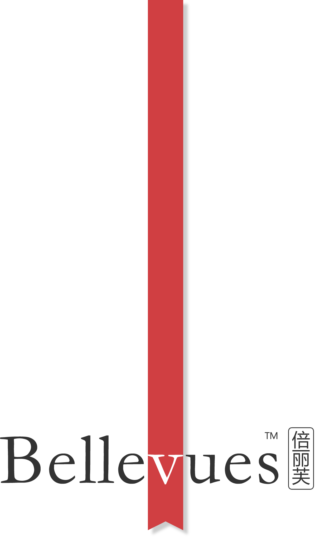

Certified Sales Agent
Quan Zeng
WeChat ID quanzeng123
has successfully accomplished the Bellevues™ products training program and Bellevues™ skin care training program, thereby demonstrating the knowledge of Bellevues™ products and Bellevues™ skin care technologies as Bellevues™ Certified Sales Agent.
Certified by Bellevues™ · Certificate ID 12345678 · Valid Until May 29 2015

